Design Documentation for Borrower Class, Spring 2014
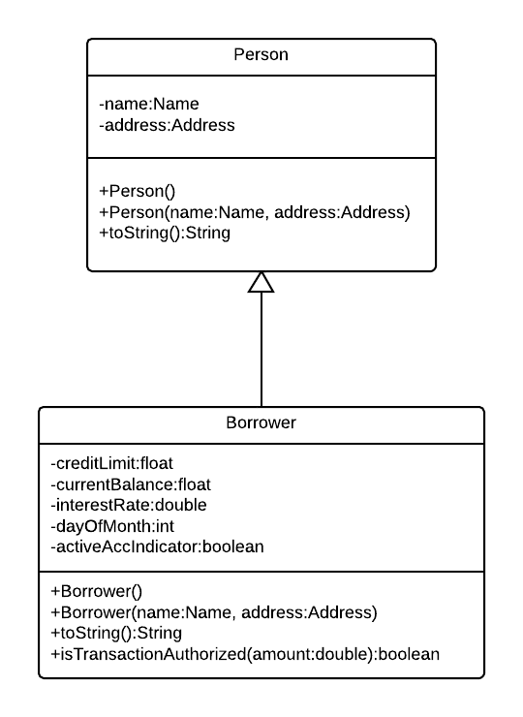
- Create a Borrower class that inherits from the Person class.
Attributes are
  - Credit limit – maximum amount that can be borrowed
  - Current balance – current amount charged by the customer
  - Interest rate – annual rate applied to balances
  - Day of the month – day of the month that the bill is due
  - Active account indicator – true or false. Indicates whether the account is currently active
- Method: No argument constructor
Specification:
- Initializes all values to “”, 0, or false
- Method: Constructor that accepts Name and Address Object
Specification:
- Initializes Name and Address based upon the Person (Name, Address) constructor
- Sets credit limit = 2000, current balance = 0, due day = 15, active account = true; interest rate = 21%
- Override the toString method
Specification: Provide an easy-to-read version of all attributes of the class
- Method: isTransactionAuthorized.
Specification:
- Parameter: Accepts an amount. Returns a boolean
- Max charge allowed for any transaction is $500. Any charge above that amount should be denied.
- Charge amount should not exceed available credit (credit limit – current balance)
- Inactive accounts can accept payments (negative numbers) but not new charges

